# Prometheus monitoring for Python application

## Setup Push Gateway

I’ve used docker for simplicity

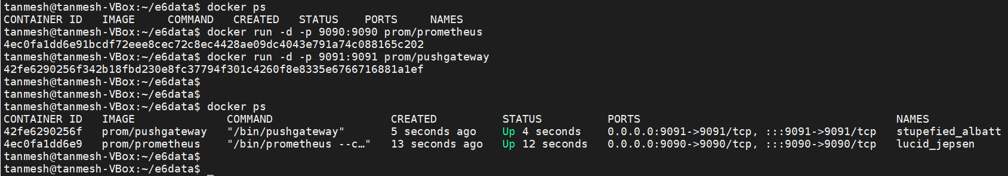

### Check whether prometheus and pushgateways are accessible from browser

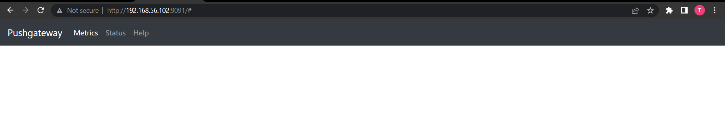

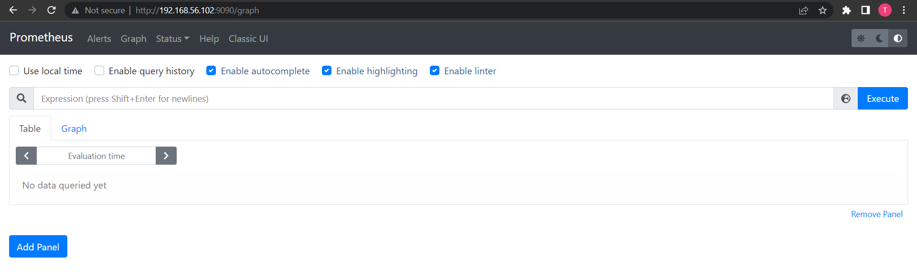

### Prometheus configs

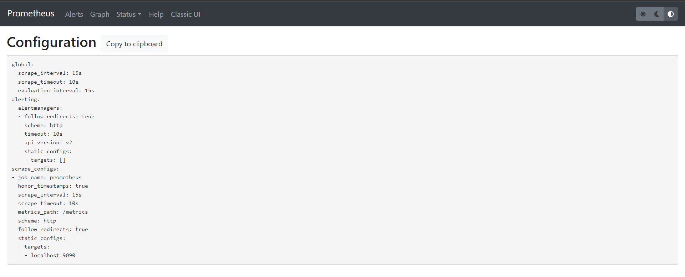

### Now configure Prometheus.yaml file for pushgateway

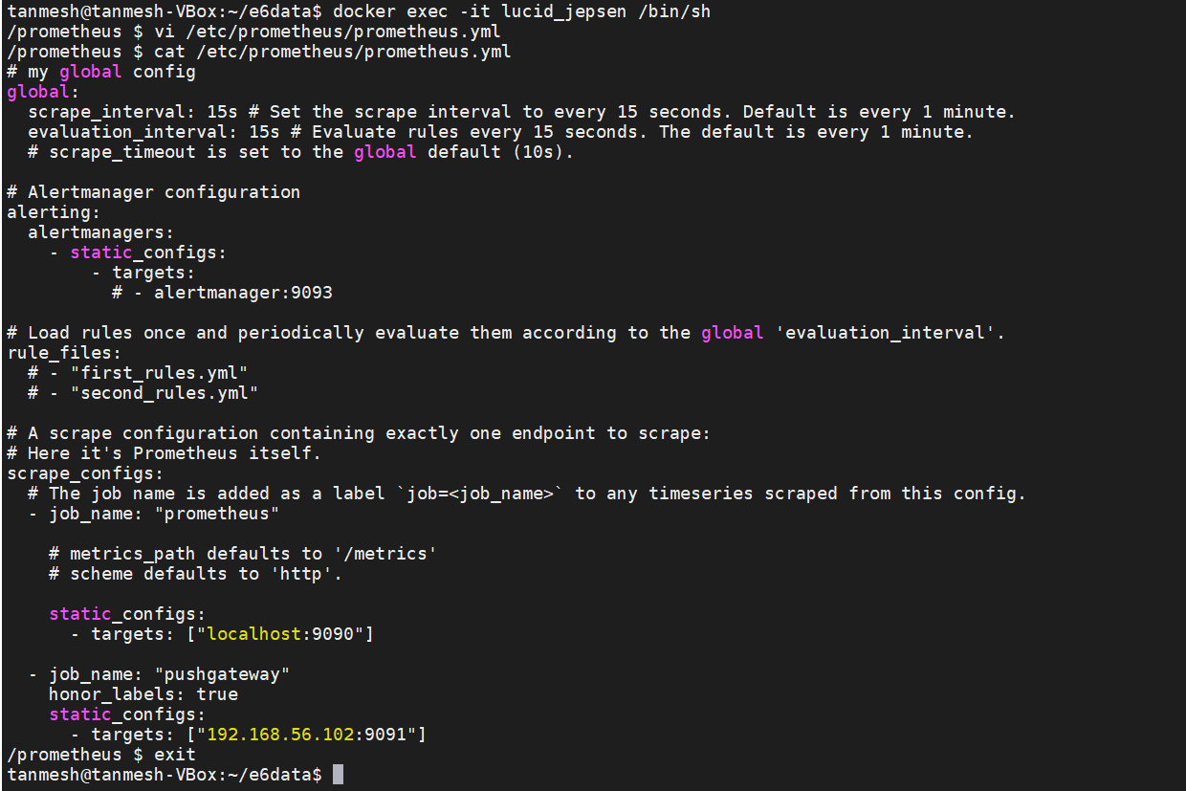

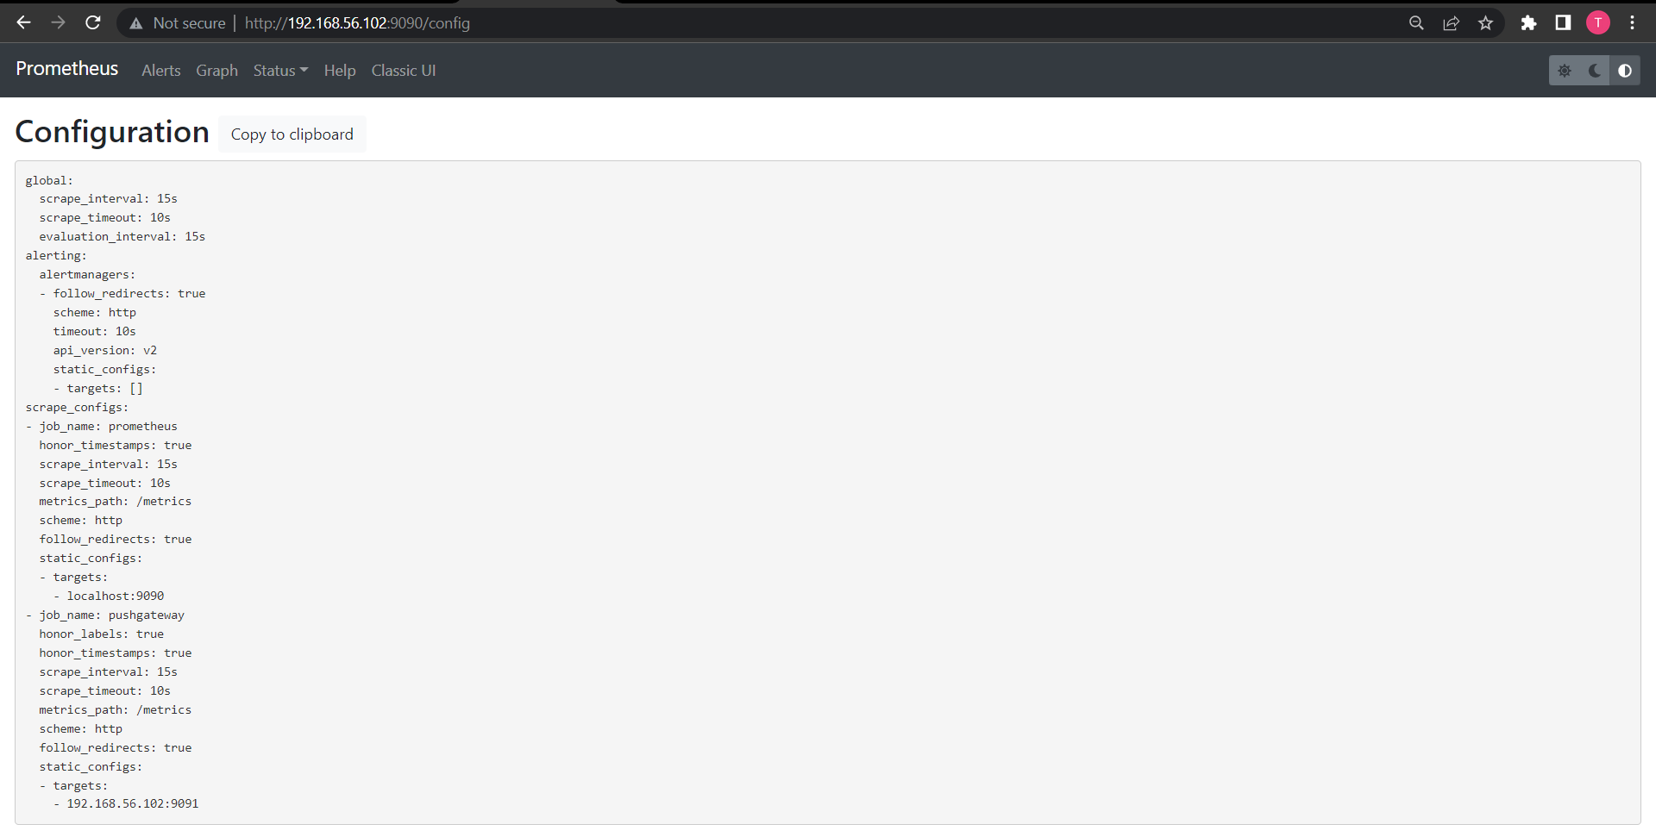

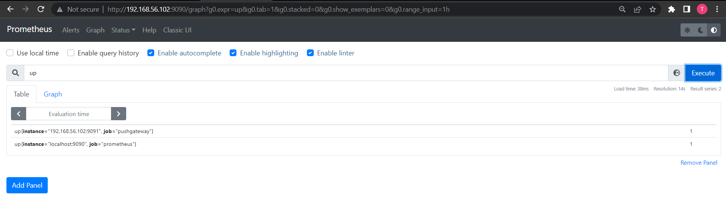

All pushes are done via http.

## Python app to push metrics into pushgateway

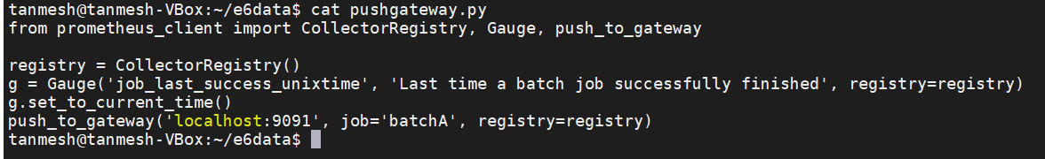

### Run the app



### Pushgateway UI

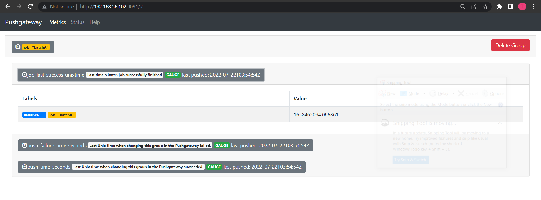

### Prometheus UI

